**16.DevOps-B24-Terraform-Part-2**

--- **note** – in this lesion, we will talk about data source.

--- **resource** – previously, we used resource block to create vpc, if you want to create resource using terraform then we will use this resource block.

--- **note** – some times, you want to create resource and terraform does not have then in this type of scenario we will data source.

**Data Source**

--- Reference - <https://www.terraform.io/language/data-sources>

--- aws vpc datasource Reference - <https://registry.terraform.io/providers/hashicorp/aws/2.36.0/docs/data-sources/vpc>

--- **scenario** – single vpc is already created in aws cloud in some region and I was asked to create a subnet in that vpc. In this type of scenario, we will create datasource.

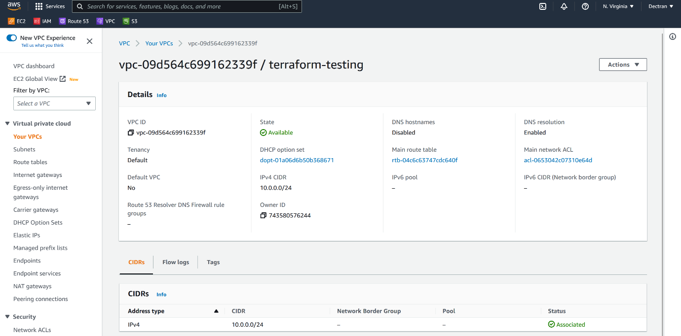

--- **note** – I need to create a vpc under this vpc so, copy the vpc id which will be used future usage.

**Vpc data source**

data "aws_vpc" "terraform-testing" {

  id = "vpc-06bdd7c2d085a8b4d"

}

resource "aws_subnet" "subnet1-public" {

    vpc_id = "${data.aws_vpc.terraform-testing.id}"

    cidr_block = "10.1.0.0/16"

    availability_zone = "us-east-1a"

    tags = {

        Name = "public-subnet-1"

    }

}

resource "aws_subnet" "subnet2-public" {

    vpc_id = "${data.aws_vpc.terraform-testing.id}"

    cidr_block = "10.2.0.0/16"

    availability_zone = "us-east-1b"

    tags = {

        Name = "public-subnet-2"

    }

}

--- **what is data source…?**

You need to deploy something which is outside of the terraform then we will use data source. In my case we have vpc which is already created in aws and we are tasked to create subnets in that vpc the we will use data source.

**Remote Datasource**

---